Expense Tracker

Project Setup:
1. Navigate to - https://github.com/Ayeshaq09/Unified-mentor-projects You will see all 8 projects.
2. To get the projects onto your system: click on "Code" button and copy the link - https://github.com/Ayeshaq09/Unified-mentor-projects.git
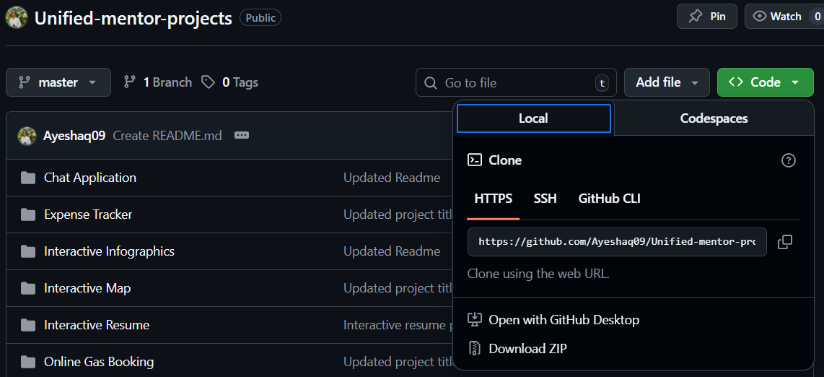
3. Open git bash and run the following command:
git clone https://github.com/Ayeshaq09/Unified-mentor-projects.git
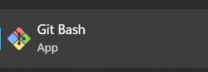
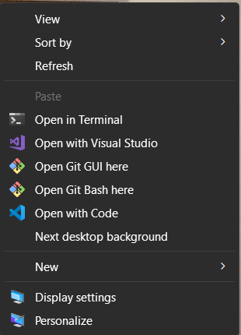
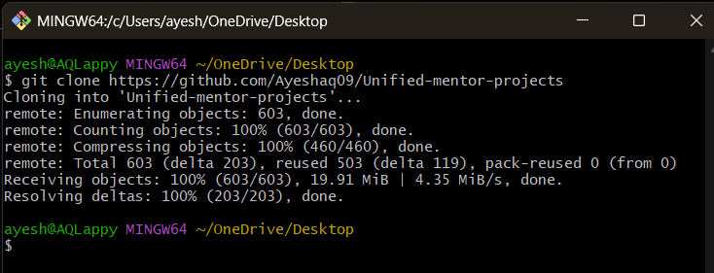
4. Once cloning is done, you get all the 8 projects onto your system.

Expense Tracker project setup:
1.Open the folder in vscode and in terminal run – cd frontend
And then run - npm install
This command will install all the dependencies in the frontend required for the project to run.
Do the same in backend – cd..
cd backend
npm install
This command will install all the dependencies in the backend required for the project to run.
2. Then add new file named – “serviceAccountKey.json” file in backend folder and add the following content in it. (Double click on the below code snippet, a new document will open with code and then copy the content and paste it in a file named “serviceAccountKey.json” in backend folder. This file is important for the firebase connection and such files cannot be added in github as they contain confidential data in it.)

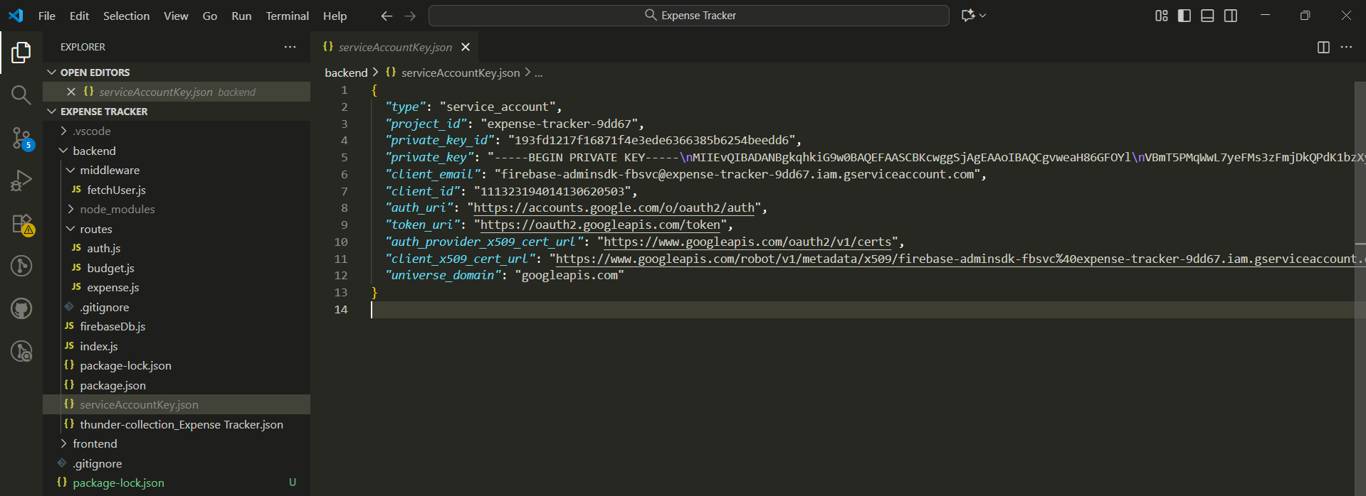
3. Then, add the “.env.local” file in backend folder.
Add the following content in it. (Double click on the below code snippet, a new document will open with code and then copy the content and paste it in a file named “.env.local” in backend folder. This file is important for the JWT Token and such files cannot be added in github as they contain confidential data in it.)
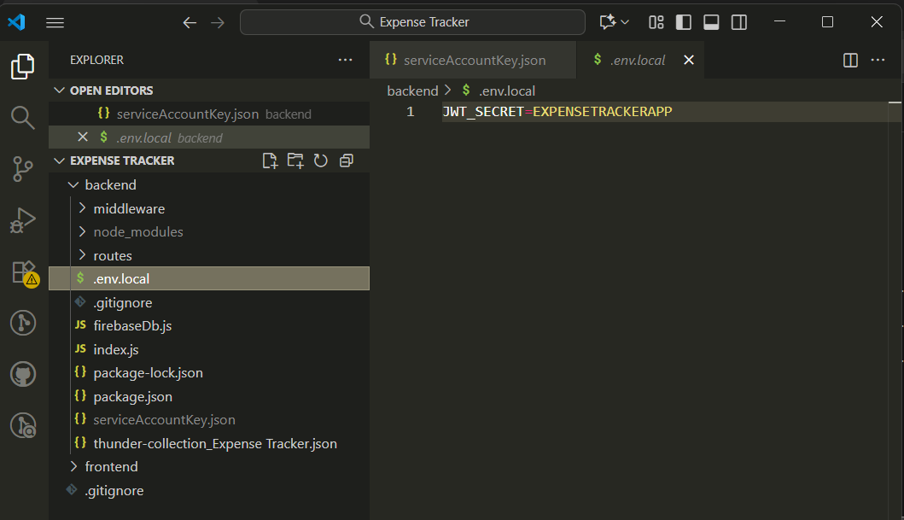
4. Then to run the project, use the command – cd..
cd frontend
npm run both

3. Type http://localhost:3000/ in chrome to view the project.

Functionality of the application:
- First you will see the login page, enter your credentials or if you are new then register.
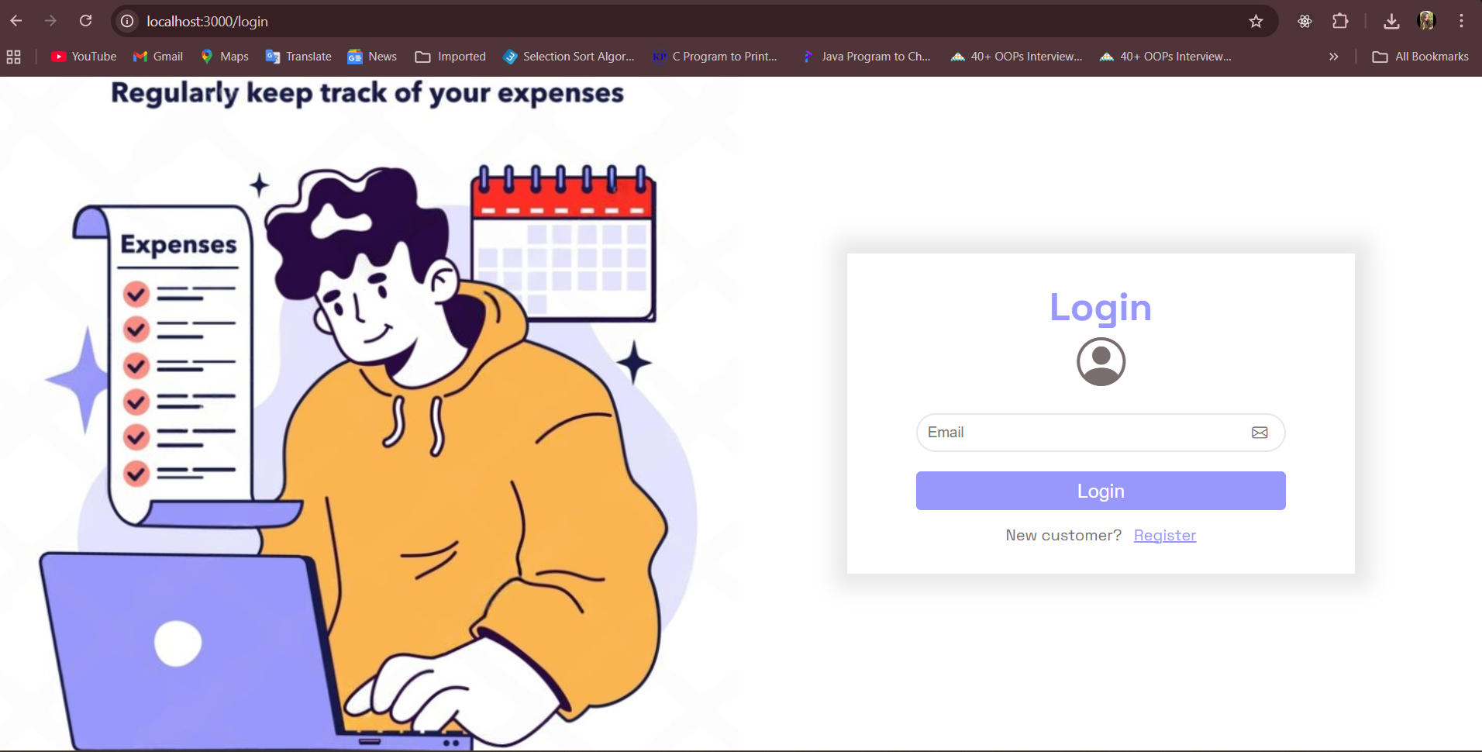
- Already added User credentials (contains already added expenses, budgets, etc):
-Email: user@gmail.com
-Email: ayesha@gmail.com
3. After logging in e.g: - as user@gmail.com, you will get the dashboard page with total of all budgets amount, spent amount and no. of budget count and a graph that displays amount spent (expenses) in each budget.
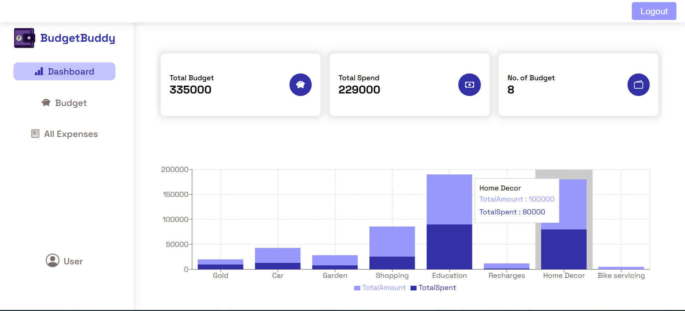
4. In Budget tab, you can see all the budgets added.
Each budget contains – budget name, total amount, spent amount, remaining amount and a progress bar.
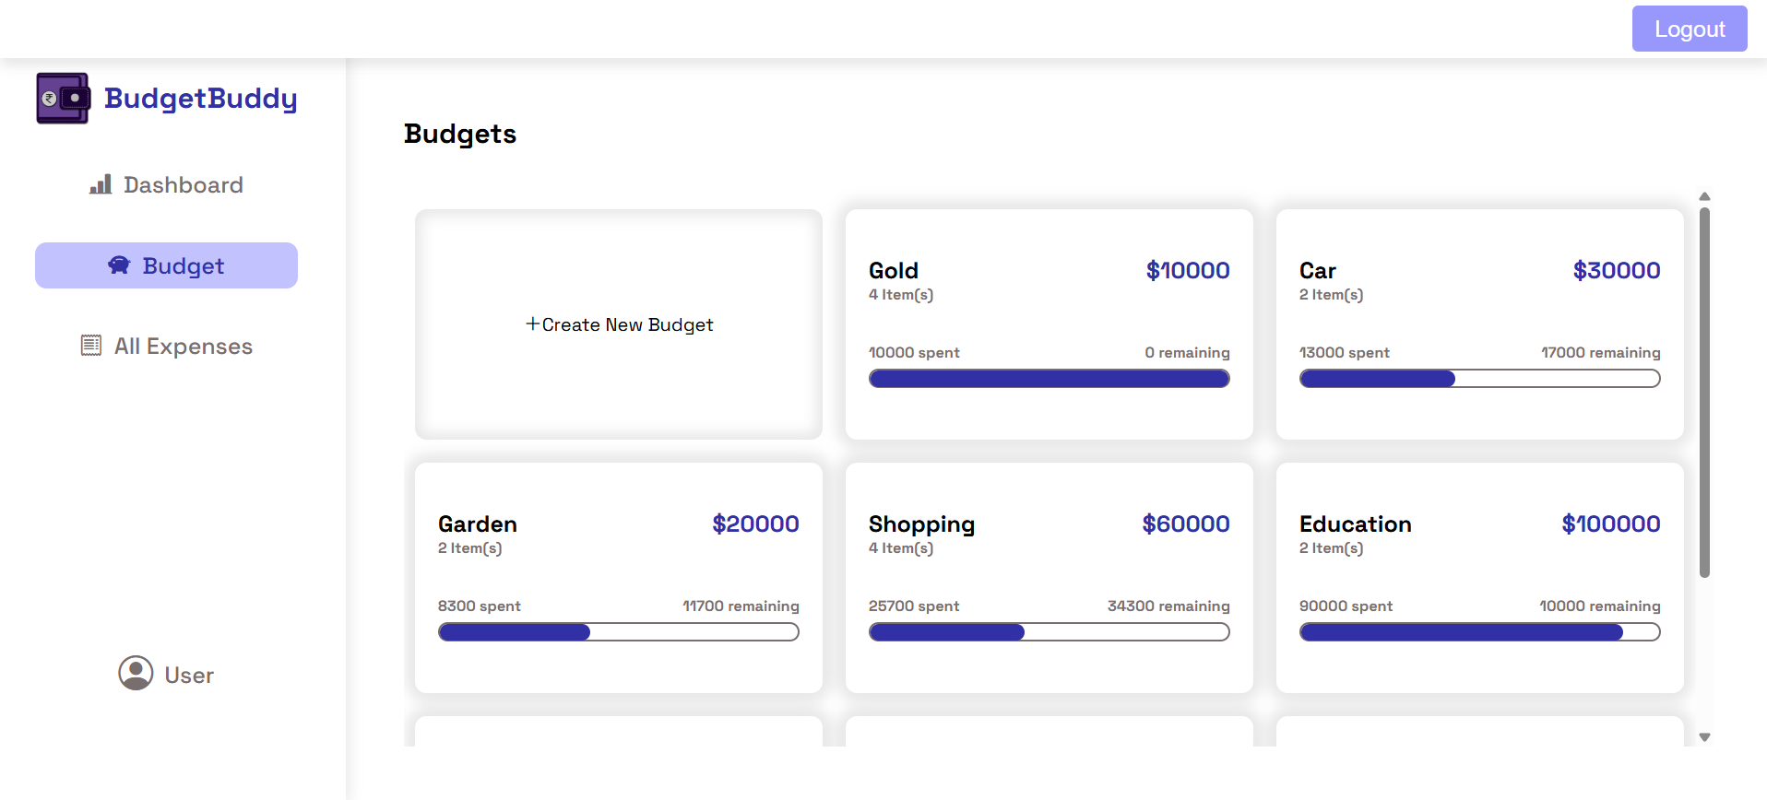

5. Click on “Create New Budget” to add new budget info – Budget name and total amount.
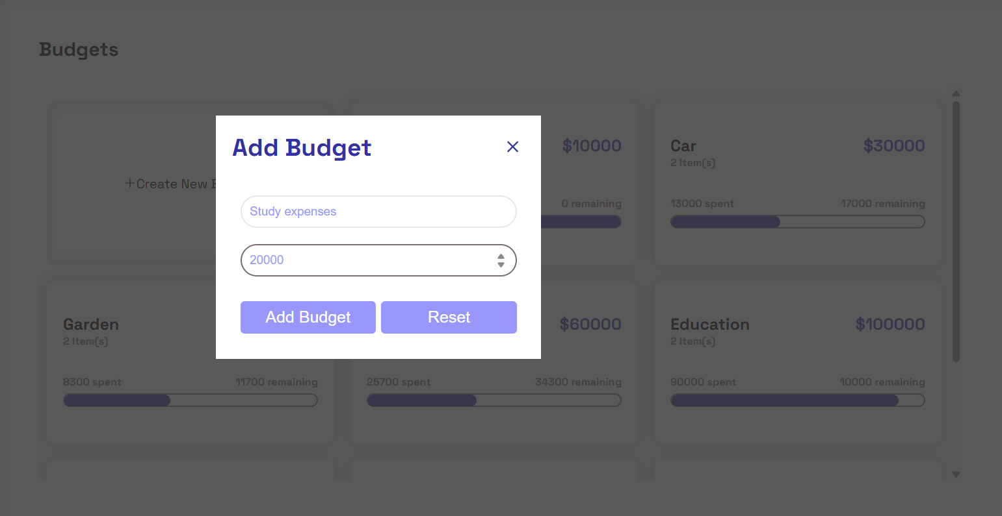

6. Click on the budget to view expenses in it. It will open the page – “My Expenses”.
Click on “<- My Expenses” to navigate back.
My Expenses - Displays budget information and expenses under it.

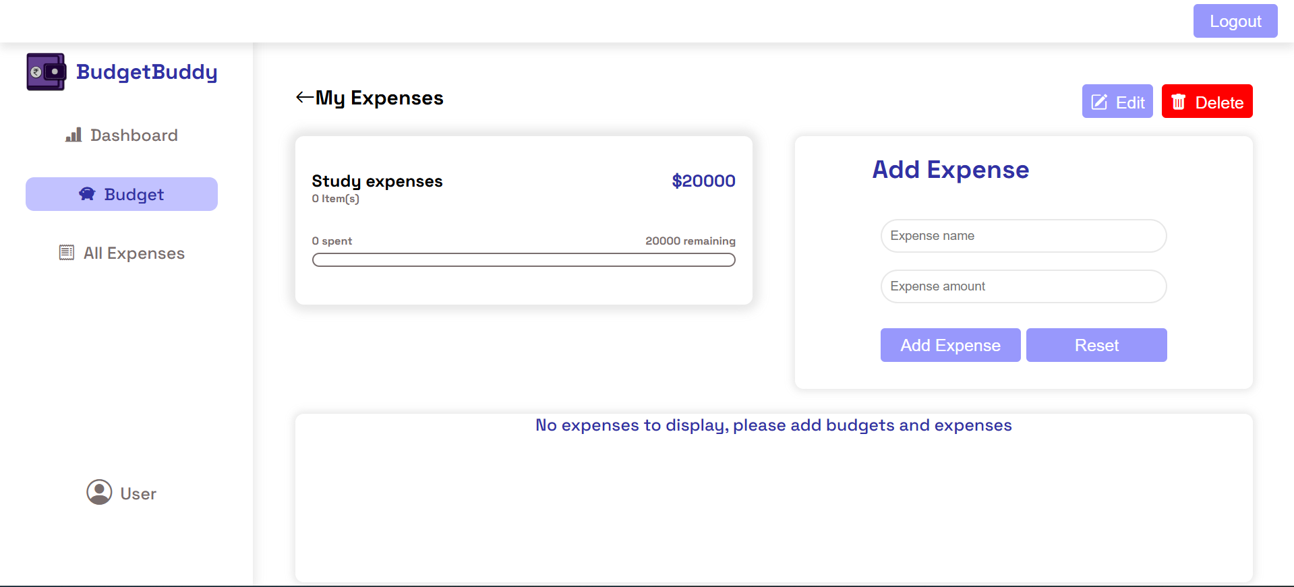

7. Click edit or delete to edit the expense info.
If the budget is deleted, all its expenses will also be deleted.
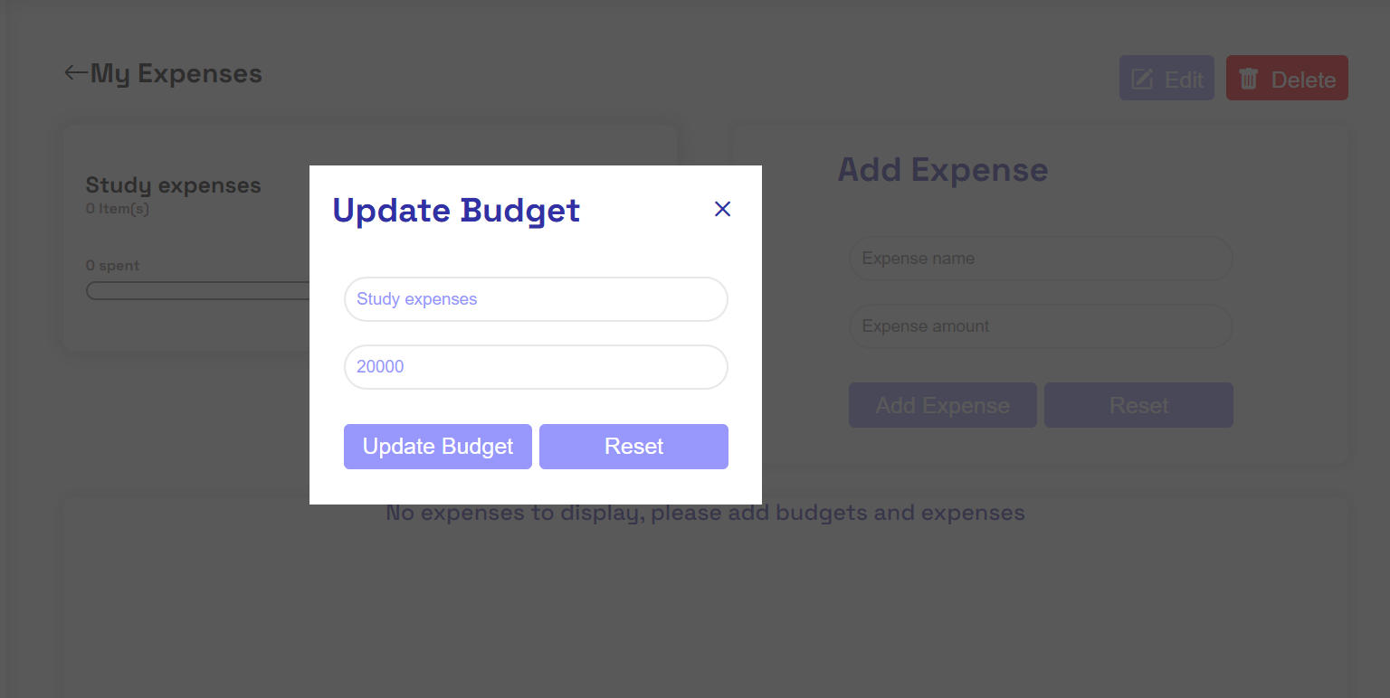

8. Click on “Add Expense” to add a new expense under the budget which will be displayed in the table below.
User can delete expenses using the “dustbin” icon.
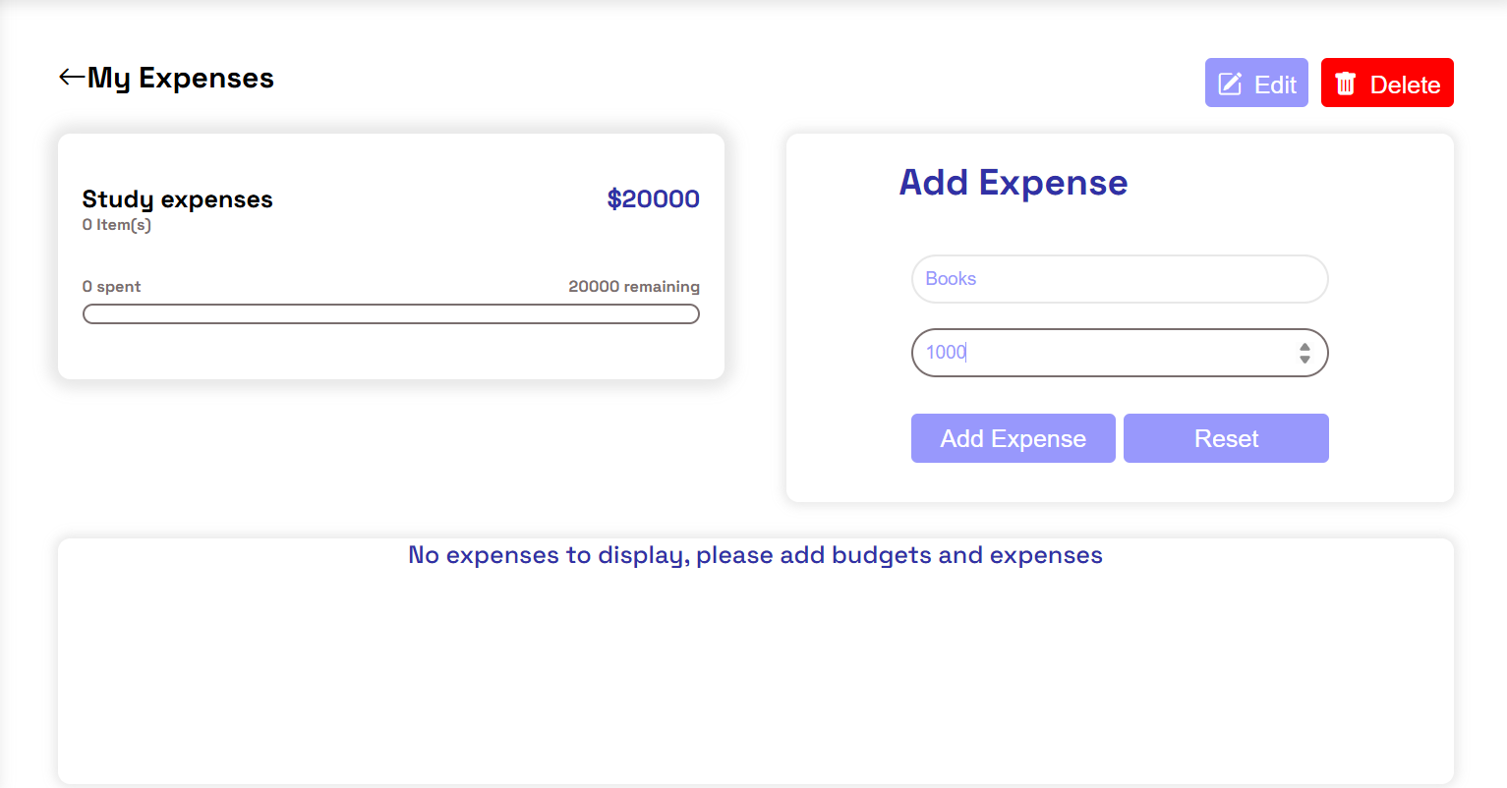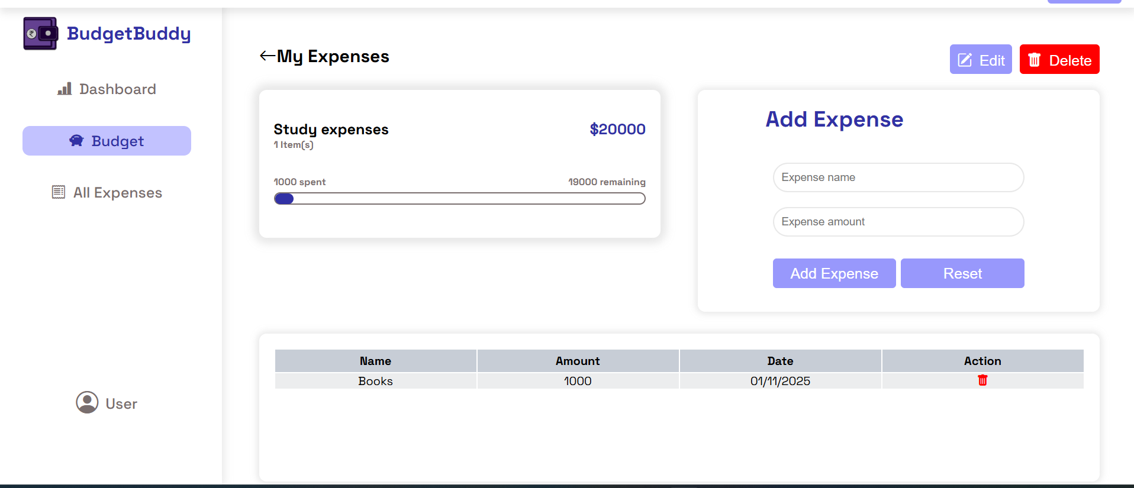
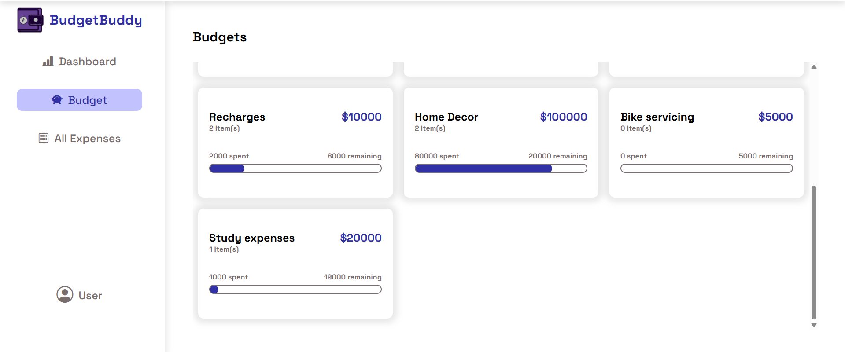

9. “All Expenses” tab displays all the expenses under all budgets.
User can delete expenses.
User can filter expenses based on budget name/category column.
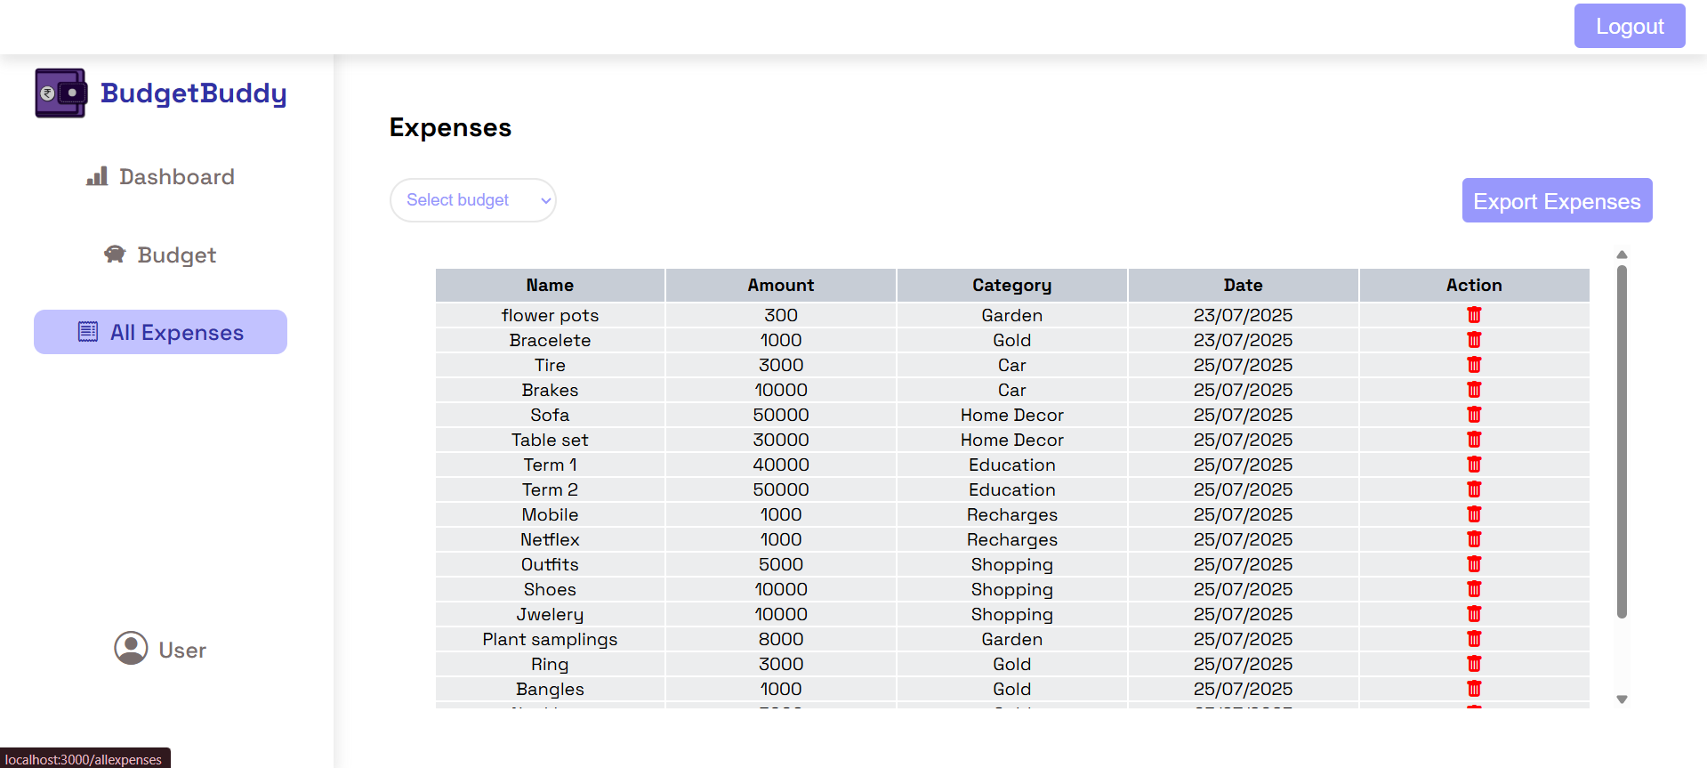

10. User can export the expenses table in .xls and view it using Microsoft Excel.
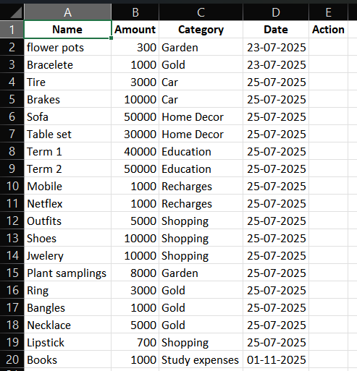
11. The user can then logout.
12. Resize the screen to check the responsiveness of the application.

